Triangles Pattern

Triangles are believed to be the most essential and

frequently emerged chart patterns in termed as the

holy grail of day trading because of their reliability

and effectiveness.

Types of Triangle Patterns

1. Symmetrical Triangle

2. Ascending Triangle

3. Descending Triangle

**Symmetrical Triangle (BULLISH , BEARISH)**

**Symmetrical Triangle "bullish"**

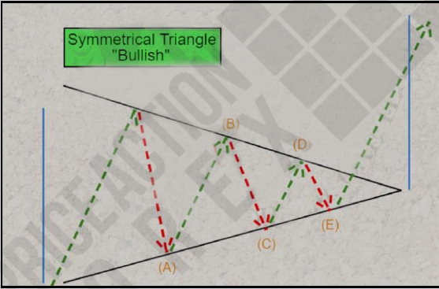

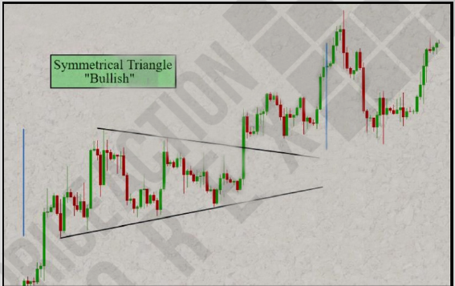

**Symmetrical Triangle "Bearish"**

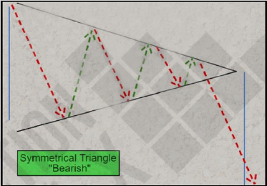

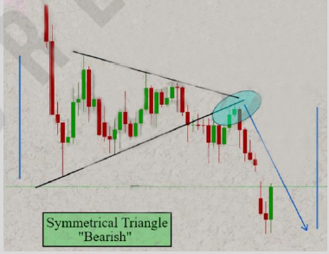

**Ascending Triangle**

**Definition:**

An Ascending Triangle is a bullish chart pattern that

consists of two trendlines:

1. A horizontal trendline at a level of resistance defined

with no fewer than two swing highs

2. An upward slanting trendline connecting a series ofhigher swing or pivot lows.

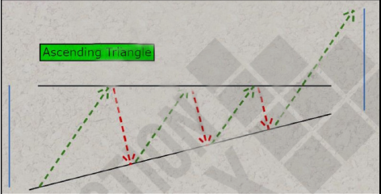

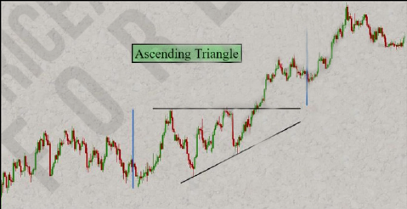

**Descending Triangle**

**Definition:**

A Descending Triangle is a bearish chart pattern that

consists of two trendlines:

1. A horizontal trendline at a level of support defined

with no fewer than two swing lows.

2. A downward slanting trendline connecting a series of lower swing or pivot highs.

